Route at Shelf to Norwood Green
From Shelf, on reaching this point turn left from the path and climb the steps to the stile
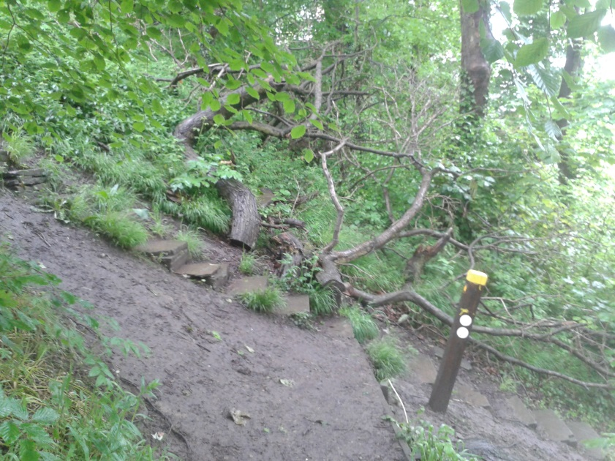
At the top of the steps, go through the stile and turn right down a concreted farm track 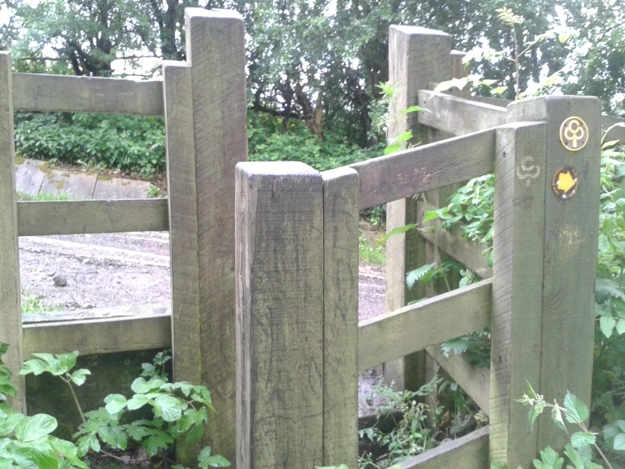

On passing the buildings and building material (there should be a digger at this point), go through the stile to the left, and stay on the right hand path, this is strewn with building rubble and drops down to the right. DO NOT TAKE THE UPPER PATH TO THE LEFT AS THIS IS NOT A PERMISSIVE PATH
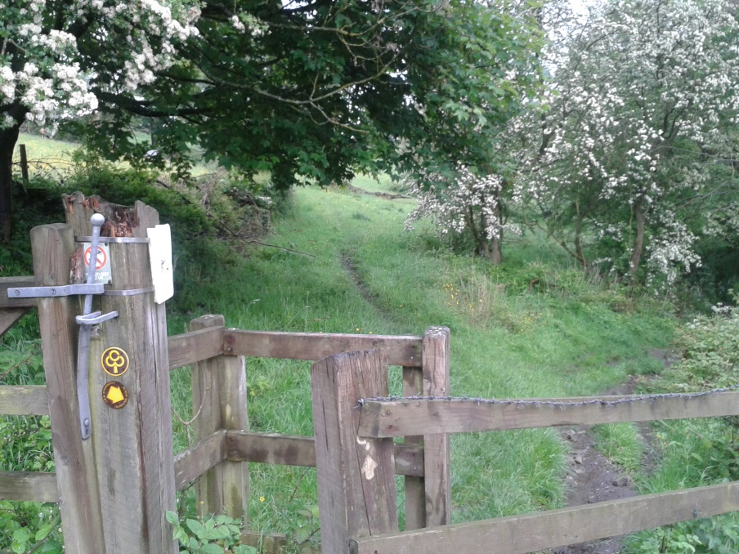
At 22.89 miles you exit the trees
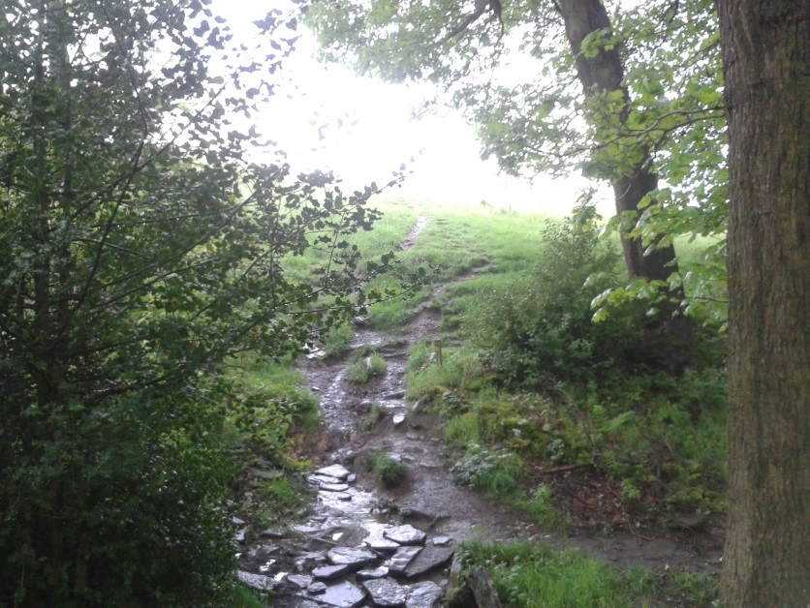
Follow this path and head diagonally towards the pylon to the stile
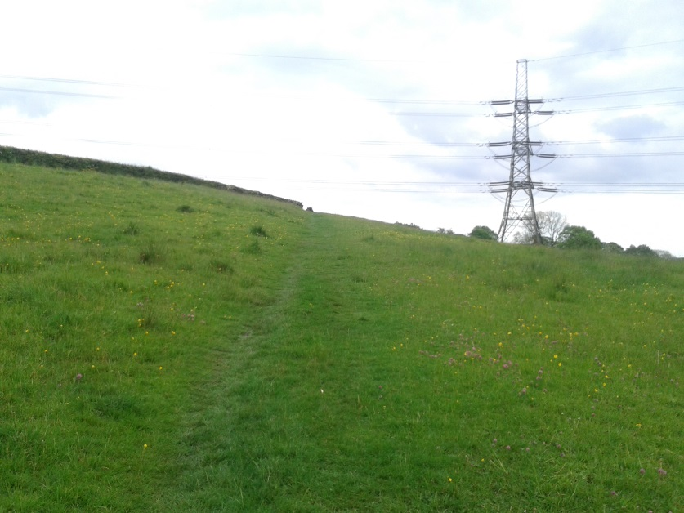
Go through the stile and keep the wall on your right, follow this path across two fields till you reach the farm. and road
